National Pathfinder Association
2024 Candidates for Election
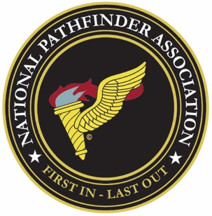

Per the NPA Constitution, I am informing all members in good standing that nominations are open for positions on the NPA Board of Governors & Officers. Each nominee, including those currently serving, must have the position(s) the individual is applying for, along with a biography, printable photograph, and signed statement by the nominee. Include some of your military service and your goals in serving the NPA. The nomination process will end January 31, 2024. Send your application to the Adjutant. This includes positions that are appointed by the Board if you wish to be considered by Board members for a position. Those positions are Judge Advocate, Quartermaster, Historian, Chaplin, Sergeant at Arms. On 1 February 2024 the slate of candidates will be published along with voting up to 1 September 2024. During our bi-annual reunion, 11-14 September 2024, the new officers will be announced and inducted.
Here are the current board positions and who currently fills that slot.
President – Preston Griffing
Vice President – Paul Shelton
Adjutant – Robert J Fogarty II
Treasurer – Ron Howard
Judge Advocate (Appointed) – Layne Jeffrey
Quartermaster (Appointed) – Phil Payne
Historian (Appointed) – Robert J Fogarty II
Chaplin (Appointed) – Ricky Todd
Sergeant at Arms (Appointed) – James Mowery
Unit Representatives and Alternate are elected by each unit/chapter members, a Unit must have 10 or more members in good standing to qualify. Here are the current unit chapters.
101st Airborne Division Representative – Bryan Bellville, Alternate –
82nd Airborne Division Representative – Laurie Emmer, Alternate –
1st Aviation Brigade (Vietnam) Representative – Fran Bujnowski, Alternate –
173rd Airborne Brigade Representative – Steve Sargent, Alternate –
11th Pathfinder Company Representative – Robert Wolaver, Alternate –
Special Operations Representative – Benjamin Robert Kidder, Alternate-
If you have any questions or wish to renew your membership, please contact the Adjutant.

ROBERT J FOGARTY II
NPA ADJUTANT & HISTORIAN
FOGART57@HOTMAIL.COM
304-716-1311

